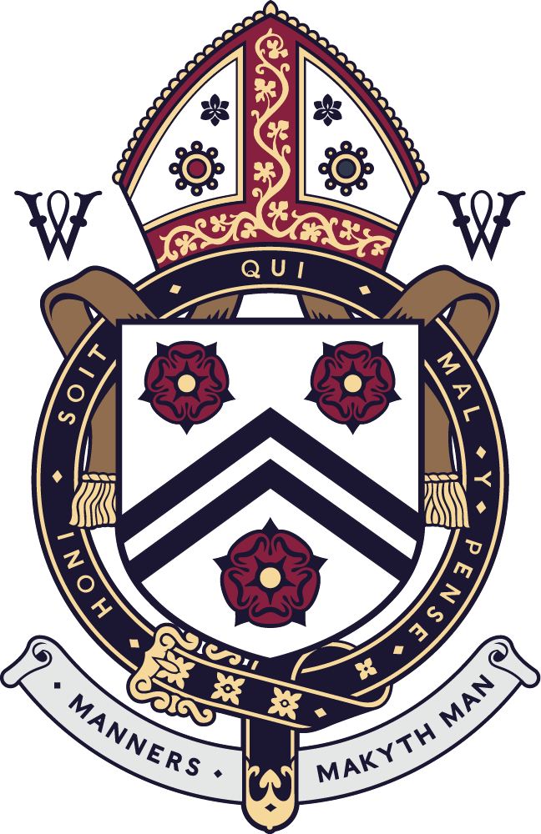

UNIVERSITY EXHIBITIONS AND LATE EXHIBITIONS 2020

UNIVERSITY EXHIBITIONS

Yui Hei (Travis) Chan H
Louis Christie G
Alfred Fardell G
Gabriel Gentile C
Oliver Goodall A
Oliver Hall K
James Howells D
Charles Inglis B
Frederick Krone D
Luca Lombardo Coll
Sebastian Longman F
Jacob Mallabone C
Harvey Starey B
Adrian Tsui B

LATE EXHIBITIONS

William Du E
George Halblander-Smyth G
Chi Lam (Ian) Kwan G
Yu Hin (Henry) Lee E
Jonty Nottingham I
Gunn (Te) Pungpapong K
Kwan Ho (Kenton) Wong I

